Police Finance Database
Qualification code
David Pereira
Oakwood Park Grammar School
Candidate number: 4103
Centre number: 61719
2020-21

Contents
Contents 2
Analysis 3
1- Description of problem being solved (pg 3)
2- End user (pg 3)
3- Researched product (pg 3)
4- Researched relevant websites (pg 3)
5- Discussion with end user (pg 4)
6- Questionnaire with end user (pg 4)
7- Made prototype of key/critical ideas (pg 5)
8- Why the third party would understand the problem being solved (pg 7)
9- Formulae being used/description of database (pg 7)
10- Objectives (pg 8)
Documented design 10
1- Flowchart (pg 10)
2- ER Diagram (pg 11)
3- Table data types (pg 11)
4- SQL Queries (pg 11/12)
5- User interface (pg 12)
6- Folder access (pg 13)
7- Required programs (pg 13)
Technical solution 14
1- Testing code (pg 14-16)
2- Examples from code (pg 17-19)
Evaluation 20
1- Objective breakdown (pg 20-22)
2- Walk through (pg 22)
3- Review (pg 22)
References/appendix 22

Analysis
- Description of the problem being solved

The problem I have chosen is to improve the current policing finance spreadsheet system to make it more secure and easier to do calculations, sort, search and read. Currently they just use a spreadsheet to store their finances and then they have to type out calculations or use another device to calculate their totals etc. My system will improve this by using a database to store the different tables into one place rather than different documents, the database will be able to do all calculations, sorting and searching much quicker than them typing it out or doing it by hand. When they request an output, it will be shown to them on a table which will be easy to read.

I have chosen this because for a possible future career I would like to do cyber security or join the police/army. My dad and sister are also part of the police so it is ideal to do a policing type project as they know exactly what is required of a system for their type of finances.

Cyber security is a major part of modern life as almost all information about our daily lives is online. So instead of just having a database full of tables of financial records that the user can load, sort, search and save, I wanted to create a secure login with passwords and security questions like a police database would. When interviewing for this project an issue with the current system that raised as quite a major improvement was that they would like to see a timeout function that automatically saves and logs the user out after 10 minutes or so. This is because if they leave to go to the toilet or take a phone call then they have to log themselves out to prevent others going through the data.

- End-user

Stephen Pereira Finance Director

- Researched product

Current system has the ability to:
- Load data – from spreadsheets all saved under different names
- Save data – to update individual months
- Sort data – by units or compare months for different units
- Do calculations entered – they manually enter calculations or have to write them down or use another system to do them

My system:
- Load data – from a database so all tables in the same place so they won’t be lost or duplicated
- Save data – to update individual months (saved in the database)
- Sort data – by units or compare months for different units
- Do calculations quickly – instead of having to manually enter calculations they will be performed by a click of a button for efficiency and to use less time

- Researched relevant websites

“A can help keep your finances organized while controlling the amount of debt you might require to live the way you want. Budgets help you plan for your monthly expenses, activities, needs, and even your financial future … a person benefits from using a spreadsheet for their finances because it places all the information in one easy-to-read place. This helps you to see how much income you have, as well as how your money is spent, which allows you to budget your money appropriately for your needs”
1(Elmblad, 2020)

From this website it gave a good explanation that my spreadsheet needs to be easily readable, with every month clearly shown for each category to be organised and to show where expenses are too high and where you have extra/spare money which could be used in another area to make up for the deficit to prevent negatives per month.
Most finance spreadsheet templates have categories in columns and months in rows to easily pinpoint areas like reading from a graph as it won’t be hard to read.

I have also researched for database queries that I can use to do the calculations in the database and then be output onto the unit that the user is using. 2(BrainBell, 2020)

- Discussion with end-user

In the interview the main point that came up is a timeout function which automatically saves and signs the user out after 10 minutes. This is because the data they are storing is sensitive and should not be seen by anyone other than himself and his boss. The current system they have to log themselves out every time the go to the toilet or take a phone call.

They also said that they like how the data is presented at the moment so they would like to keep the format similar, but they would like a simple search/compare function to easily see data relevant to their current issue e.g. compare of yearly totals of Officers and Dog Unit.

Finally the last main point was that some spreadsheets are saved into different areas of their storage, so to improve this I would create a database to store all tables into the same area.

- Questionnaire with end-user

What is it used for?
Collating, recording and allocating data

What does it need to do?
Add total expenses by category. Calculate VAT

What can be improved from the current system?
Time out after 10mins

How often do you use it?
Weekly data collating, monthly reporting

How many people can access it?
Him and boss

Is the current system very easy to read?
Very easy to read

Would you benefit from the calculations being performed by a button?
Yes

Is the current system easy to search for specific data?
Yes

Is the current system easy to sort data?
Yes

What would you like to keep the same?
Layout

- Made prototype of key/critical areas

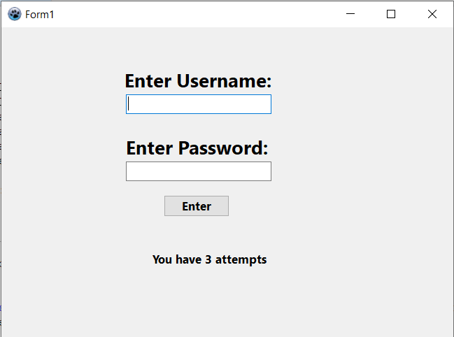
As seen in the screenshot, the user will first have to enter their login. The password will be blocked out by ‘*’ so anyone looking at their screen cannot see it. They are also told how many attempts they have before the program closes.

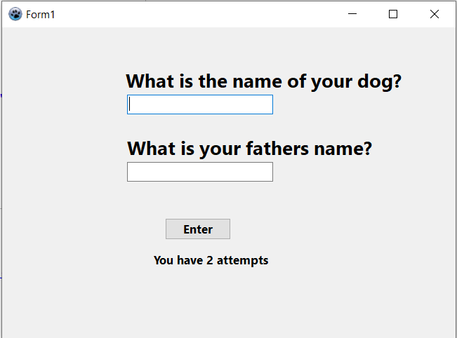
If they enter the correct username and password then they will have to answer two security questions. Again they are shown how many attempts they have.
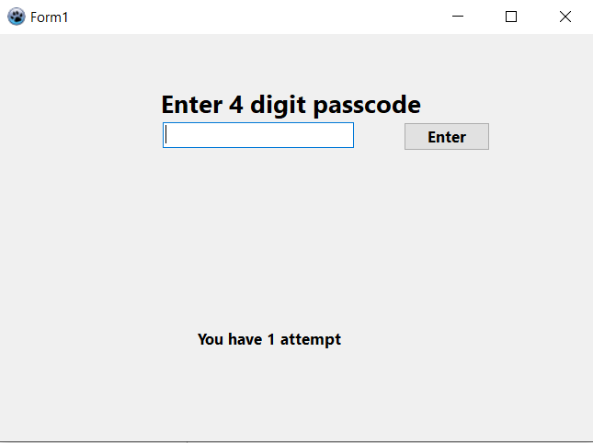
Final layer of security is the passcode, again showing attempts.

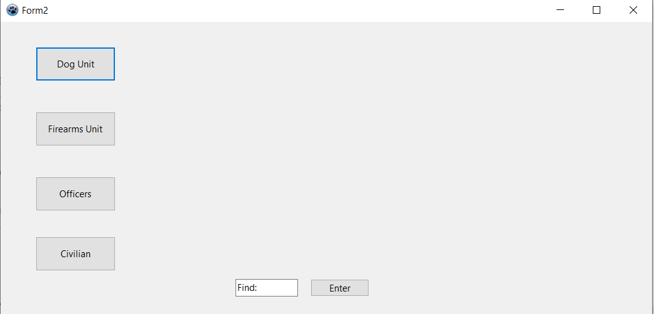
When they have entered all the correct details the second form/unit will load which gives them a menu option for what data they want to see. This also has a search option for comparing.

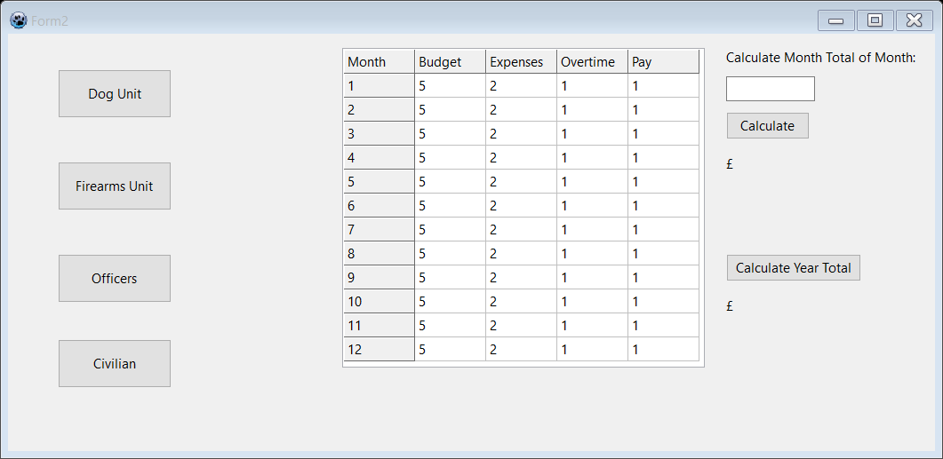
When they select the unit they want the information for that unit is shown and they can calculate a total for a single month or the whole year.

- Why the third party would understand the problem being solved

The third party has full understanding as he uses the current finance documentation system every month to fill out reports, check the data is correct and be able to find areas which they have spare/extra money to spend on other aspects of their office or other units who may have gone over budget.
This means that in my program I will need features that allow the data stored to be loaded, edited and saved. There will need to be a searching algorithm to compare budgets etc. as well as calculations to be able to show totals for the months and year as a whole.

- Formulae being used/description of database

Database → tables: Dog unit, Officers, Firearms, Civilian
Each table → months – expenses, budget, overtime, pay
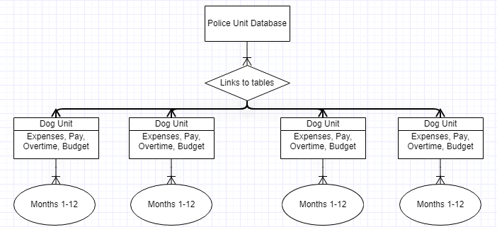
Civilians
Firearms
Officers

Month total = Budget – (expenses + overtime + pay)
Year total = all month totals added
Month average = (all month totals added) / 12

Entity relationship diagram explained in depth on the design section.

- Objectives

  - System start
- Login unit should load
- Username entry box should load with label
- Password entry box should load with label
- Enter button should load

  - Login
- User able to enter username and password
- Password should be hidden with ‘*’ when typed
- Only given 3 attempts to enter this stage
- If correct it should load a file with security questions
- Enter two security questions
- Only have 2 attempts for security questions
- If correct load pin code
- Enter pin code
- Only 1 attempt
- If after the stated amount of attempts they are wrong then the program should close

  - Selection unit
- If all login details were correct then the selection unit should load
- 4 options should load that the user gets to select to see the information
- A search button should also be available

  - Database
- The 4 options in the selection unit should load to a database which has linked tables
- Depending on what the user selects to search in the table the database will link to another table under that selection which will give an overview
- The user can then select to load the whole data from a linked table to that table which will then show the data for every month

  - Load onto sheet
- When data selected it will be loaded onto the sheet
- They will have the option to calculate monthly totals
- They will have the option to calculate the year total
- They will have the option to search and compare specific months from different units

  - Saving
- When data is entered they can save it back and update the database
- When they want to exit the program they have the option to save their data
- When they exit they have the option to exit without saving
- When data is saved, the next time they load the program the new data is loaded from the database

  - Exit
- When they want to exit the program they have the option to save their data
- When they exit they have the option to exit without saving
- Exit closes and logs out whole program

  - Auto exit
- If the program is left for 10 minutes then the program will automatically save and logout
- When mouse is being used then timer resets

Documented design

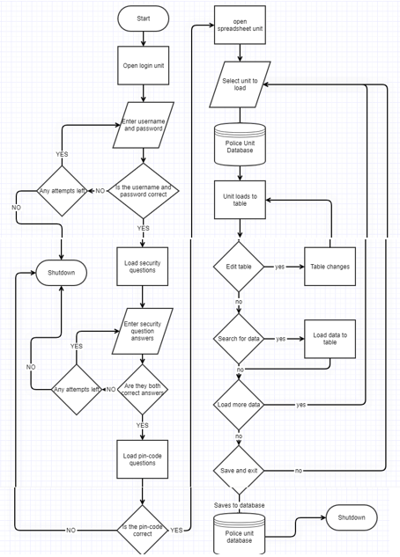
This is a simple overview flowchart of how my program will work. First there is the login unit which the user must enter all the correct data to with a limited number of attempts. Once they have completed this they are able to access the database which they can use to load units to, search for specific items or calculate totals. When they exit they have the option to save their data and then the program will close.
Civilians
Firearms
Officers
The database will operate on this format. This entity relationship diagram shows how each table is linked and the attributes they have. As shown in the diagram the database stores four tables which have the subcategories of expenses, pay, overtime and budget. All of these will have data for the 12 months of the year.
Variable | Data type | Description
Expenses | DECIMAL | That months cost to run the department
Pay | DECIMAL | The pay to any employees in that department
Overtime | DECIMAL | Overtime pay to employees in that department who worked outside their normal hours
Budget | DECIMAL | Total budget allowed for that month for the department to spend
Months | INTEGER | Months of the year as 1-12

SQL Query | Function
SELECT | Allows a table in the database to be selected
* | Selects all data in the table selected
FROM | Allows the user to specify what table they want to access
AND | Select multiple tables or data
ALTER | Changes column data types, removes and adds columns
INSERT | Inserts data into the table in the database
WHERE | Specifies which row/column the data Is located in the table
X*Y | Multiplies two pieces of data in the database tables by each other
X/Y | Divides two pieces of data in the database tables by each other
X+Y | Adds two pieces of data in the database tables by each other
JOIN | Allows two tables to be accessed and shown together in one table
UPDATE | Changes the data in the table

Queries in use:
SELECT * FROM ‘table’; //selects all data from the table wanted and displays to the user

SELECT budget-(pay+expenses+overtime) FROM dog where month = x; //calculates total for the month

SELECT (SUM(Budget-(Pay+Expenses+Overtime)))/12 FROM dog; //calculates the total average for the year

SELECT SUM(Budget-(Pay+Expenses+Overtime)) FROM dog; //calculates the total for the year

SELECT dog.*, officer.* FROM dog JOIN officer ON dog.month = officer.month; //selects data from multiple tables for comparison (search)

UPDATE dog SET Budget = 5000 WHERE Month = 1; // Updates the budget column in the table dog for the first month

Example:
DogUnitButtonClick:
SQLQuery ← SELECT * FROM dog

Or:
search dog officer pay:
Word1:= searchbox[1];
Word2:= searchbox[2];
Word3:= searchbox[3];
If word[3] = pay then
If word[1] = dog and word2 = officer then
SQLQuery ← SELECT dog.pay, officer.pay FROM dog JOIN officer ON dog.month = officer.month

These are simplified examples of how the user is able to select a unit or enter key words to create a SQLQuery to be able to search the database and get the output for specific items.

Button Name | Button Colour | Button Function
Enter | White | Data in textbox is read by the program
Dog Unit | White | Loads all information from the database from Dog Unit
Civilian | White | Loads all information from the database from Civilians
Officers | White | Loads all information from the database from Officers
FireArms | White | Loads all information from the database from Firearms
Calculate | White | Reads textbox, calculates answer then outputs it
Search | White | Searches for a specific set of data from the tables
Sort | White | Sorts the information displayed lowest to highest
Unit Name | Unit Colour | Unit Function
LoginUnit | Blue | Loads first for the user to enter login details
SpreadsheetUnit | Blue | User accesses the database through here and all data is displayed to this unit in spreadsheet format
Label Name | Label Colour | Label Function
LoginLabel1 | White | Give instructions
LoginLabel2 | White | Give instructions
CalcMonth | White | Give instructions
CalcYear | White | Give instructions
Table Name | Table Colour | Table Function
Spreadsheet | Grey/White | Displays information from database
Timer Name | Timer Colour | Timer Function
TimeOut | No Colour | Terminates program after 10 minutes

Folder access:
Username ← input
Password ← input
Extension ← Username + Password
If extension <> ‘correct name’ then
begin
Attempt + 1
If attempt = 4 then
Output → locked out
Closeprogram
else
Folder ← C:\Users\David Pereira\Documents\P\Project Files\.loginfile\ + Extension + .txt
Assignfile ← (myfile, Folder);
Reset(myFile)
readln(myfile, answer)
readln(myfile, answertwo)
readln(myfile, answerthree)
end

The File is accessed and then all the lines are read for the next answers in the login. The users input is used to compare to the answer read from the file. If correct they move on. If not the question ns they have two attempts, and the pin code they have 1 attempt. If failed then the program terminates. If all successful then the spreadsheet unit connected to the database loads.

REQUIRED:
The program requires Lazarus and MySQL. Lazarus is used to compile the code in pascal and MySQL is used to store, read and write the database which the tables are found.

Technical solution
Test | Type/test data | Expected | Actual
System start | N/A | Login unit should load//Username entry box should load with label//Password entry box should load with label//Enter button should load | 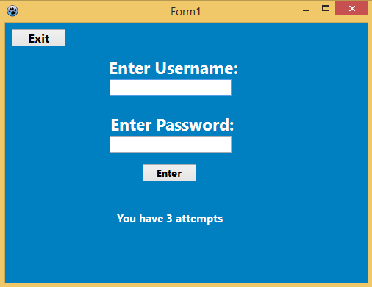
Enter username and password | DDDD/DDDDD – invalid entry  Steve/P3r3ira01 - valid | User able to enter username and password  Password should be hidden with ‘*’ when typed  Only given 3 attempts to enter this stage  Connects to file  If correct it should load a file with security questions  If wrong 3 times then program closes | https://youtu.be/CQSFq04bm_o  Code of how this works In the table below
Enter security questions | 123/yes – invalid  Samson/Doug – valid | Enter two security questions  Only have 2 attempts for security questions  If correct load pin code  If wrong twice then program close | https://youtu.be/qG9b0ujaCw8
Enter pin code | 2222 – invalid  2684 – valid | Only 1 attempt  If wrong then program close. If correct then next unit load | https://youtu.be/RDGs03YjTzo
Exit buttons | N/A | When pressed the program will close where it is | https://youtu.be/6zHjzQYEihs
Unit buttons | N/A | When pressed the unit selected by the user is displayed in the spreadsheet for the user to see | https://youtu.be/T_5Sccs3lOE  Code of how this works In the table below
Compare data | 1/s/f – error  */dog/officer – valid | Able to type what two tables and what data the user would like to compare and display them in the spreadsheet | https://youtu.be/9PRHvNFmKmM  Code of how this works In the table below
Month total | Jan – error  1-12 – valid | Calculate the month total of the selected dataset and month that the user wants | https://youtu.be/wXnOTIkT5f4  0:10-0:33  Code of how this works In the table below
Year total | N/A | Calculates the total money remaining/over they spent for the year | https://youtu.be/wXnOTIkT5f4  0:33-0:50  Code of how this works In the table below
Year average | N/A | Calculates the average of each month of the year to show spending habits | https://youtu.be/wXnOTIkT5f4  0:50-1:05  Code of how this works In the table below
Edit data | Incorrect format/not exact words – error  1/Budget/5002 – valid | User can select what month and column they would like to edit, they can then enter the data to change to | https://youtu.be/6bz0AGmjGAs  Code of how this works In the table below
Back button | N/A | Goes back to the menu to be able to select the next option | https://youtu.be/ltEECC988pw
Lock Button | hello – error  2313, 2222 – invalid  2684 – valid | When pressed, the main program is closed and the locked screen shows which requires a passcode to get back into. Three wrong attempts closes the program. | https://youtu.be/Me0PordziqQ  0:00-0:57
Timer | N/A | When locked the timer begins and the user has three minutes to enter the passcode before program closes | https://youtu.be/Me0PordziqQ  0:57-1:21

Enter username and password | 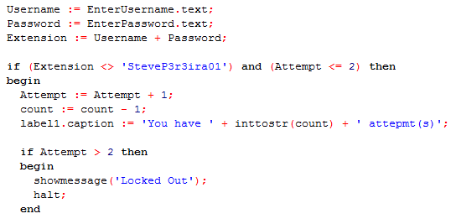  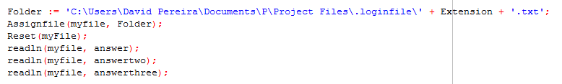
Unit buttons | 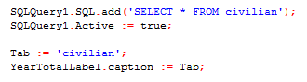
Compare data | 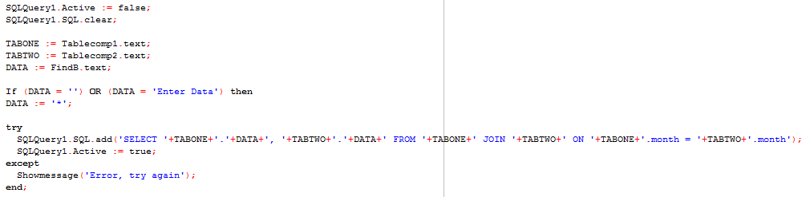
Year total | 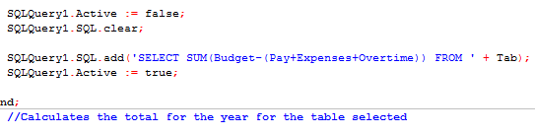
Year average | 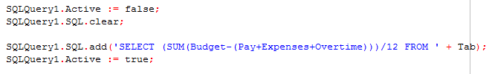
Month total | 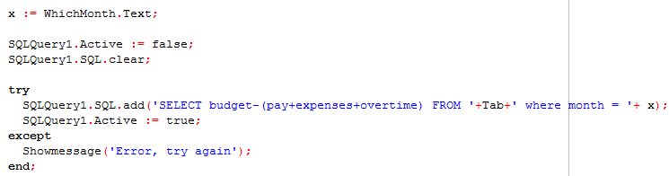
Edit data | 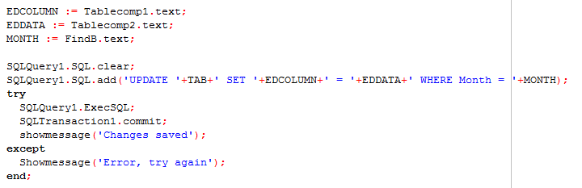

Evaluation

My project was to simplify the policing finance system to make data quicker and easier to read and update, ensuring I kept it secure at the same time. I achieved the security of the system by creating a login system that requires a username, password, security questions and a pin code. This would be a lot harder to breach than just a passcode as the security questions are personal. The file handling worked well and all answers were read and used properly in the part of the login system they were required at.
The database worked as intended and all four tables were able to be connected to from the program, they were well represented and loaded clearly onto the sheet so it was simple for the user to use. The comparing and editing functions worked well and were simple to use, however, to improve I would make it so the user can enter the section of the table they want and it would change spelling mistakes so it would still display, rather than them having to type it in exactly as it is in the table.
The lock and timeout function was a development I made during the program. My first intent was to create a timeout function that would stop after the user had been idle for some time, however I was struggling to do this and then came up with a better idea that suited the program more. This was creating a lock button which would stop the program and would only allow you back in if you entered the correct passcode. This keeps with the policing theme and the added security they would need if they left their desk without having to completely log out. It still has a countdown, so after the stated amount of time, if they’re not back then it would close for security.
To further improve my program I would create interlinked tables to separate the data into further categories. For example, total pay for the month will be broken down into individual pay to employees. Or expenses will show what exactly has be bought. Another improvement, which was intended but I was unable to do, is to make a save and exit function, so the updates wouldn’t be saved straight away, they would be stored and when the user wants to exit they have the option to exit and save the changes or exit without saving to revert back to the original.
Objective breakdown:
System start  Login unit should load  Username entry box should load with label  Password entry box should load with label  Enter button should load | Login successfully loads, all components show  Loads with label and can be used  Loads with label and can be used
Login  User able to enter username and password  Password should be hidden with ‘*’ when  typed  Only given 3 attempts to enter this stage  If correct it should load a file with security questions  Enter two security questions  Only have 2 attempts for security questions  If correct load pin code  Enter pin code  Only 1 attempt  If after the stated amount of attempts they are wrong then the program should close | Username and password can be entered, password is covered by ‘*’. After 3 attempts the program closes  Correct answers load the security questions and the answers are read from the file  Both security questions load and two attempts allowed  Pin code loads, one attempt allowed, answer read from file  In all cases, after the stated amount the program does close with a display message
Selection unit  If all login details were correct then the selection unit should load  4 options should load that the user gets to select to see the information  A search button should also be available | Selection unit loads as the main menu  All four options connect to their separate tables in the database and display their contents when clicked  Search function allows to search for individual data for two tables and allows comparisons
Database  The 4 options in the selection unit should load to a database which has linked tables  Depending on what the user selects to search in the table the database will link to another table under that selection which will give an overview  The user can then select to load the whole data from a linked table to that table which will then show the data for every month | All four options connect to their separate tables in the database and display their contents when clicked  When they enter what they want to search, the overview from that table is displayed as well as the comparison to another table  When a unit is selected, all data for the entire year is displayed and clearly labelled by the month
Load onto sheet  When data selected it will be loaded onto the sheet  They will have the option to calculate monthly totals  They will have the option to calculate the year total  They will have the option to search and compare specific months from different units | When a unit, calculation or compare pressed, it loads onto the sheet  They can calculate monthly totals easily  Option available for each table  Option available and works as intended, can compare entire tables too
Saving  When data is entered they can save it back and update the database  When they want to exit the program they have the option to save their data  When they exit they have the option to exit without saving  When data is saved, the next time they load the program the new data is loaded from the database | Edit data saves to and updates the database  I was not able to create this function, this would be an improvement I can make  Just exits program  When data is saved, the database updates, so when loaded again the updated database is loaded
Exit  When they want to exit the program they have the option to save their data  When they exit they have the option to exit without saving  Exit closes and logs out whole program | Data is saved when changed by the edit data button, to improve my program I would create a save and exit button  Just exits the program  Whole program closes as intended
Auto exit  If the program is left for 10 minutes then the program will automatically save and logout  When mouse is being used then timer resets | In the program I use 3 minutes for testing purposes, but it can easily be increased to 10 minutes and it works as intended  Created a lock unit which required a passcode to re-enter as this would be safer for a police style system

Walk through: https://youtu.be/QaJDqRLriPA
The finance director’s review of my project said that he was impressed and like how easy it was to navigate and read. He was very complimentary about the lock button function and said that would be a major improvement to the system as the timer works well, and if he did need to get back in quickly then it was easy to do so.
To improve my project he said the tables would be better with more detail, eg splitting up into individual pay to employees for each month. As well has having a keyword search or a function that he could enter a figure and find all the sectors that have around that amount spent and they display for him. Eg search for expenses above 4000.
In overall he was happy with how the program performed and said it was an improvement to their current system for speed and readable purposes, but would need to have more functions and details which I believe I could have done if I had longer to spend on this project.

References/appendix

- Elmblad, S., 2020. Use These Finance Spreadsheets To Manage Your Finances. [online] The Balance. Available at: <https://www.thebalance.com/free-budget-spreadsheet-sources-1294285> [Accessed 27 September 2020].
- BrainBell (2020). Performing Mathematical Calculations : MySQL. [online] www.brainbell.com. Available at: https://www.brainbell.com/tutorials/MySQL/Performing_Mathematical_Calculations.htm [Accessed 9 Oct. 2020].

